FORM 3 | UNITED STATES SECURITIES AND EXCHANGE COMMISSION  Washington, D.C. 20549  INITIAL STATEMENT OF BENEFICIAL OWNERSHIP OF SECURITIES | OMB APPROVAL  OMB Number: 3235-0104  Estimated average burden  hours per response... 0.5
 | Filed pursuant to Section 16(a) of the Securities Exchange Act of 1934 or Section 30(h) of the Investment Company Act of 1940

1. Name and Address of Reporting Person *  McReynolds Maya |  | 2. Date of Event Requiring Statement (MM/DD/YYYY)  10/10/2024 |  |  |  | 3. Issuer Name and Ticker or Trading Symbol  F5, INC. [FFIV]
(Last) (First) (Middle)  C/O F5, INC., 801 5TH AVE. |  | 4. Relationship of Reporting Person(s) to Issuer (Check all applicable)  __X__ Director _____ 10% Owner  _____ Officer (give title below) _____ Other (specify below)
(Street)  SEATTLE, WA 98104  (City) (State) (Zip) |  | 5. If Amendment, Date Original Filed(MM/DD/YYYY) |  |  |  | 6. Individual or Joint/Group Filing(Check Applicable Line)  _X_ Form filed by One Reporting Person  ___ Form filed by More than One Reporting Person
Table I - Non-Derivative Securities Beneficially Owned
1.Title of Security  (Instr. 4) |  |  |  | 2. Amount of Securities Beneficially Owned  (Instr. 4) |  |  |  | 3. Ownership Form: Direct (D) or Indirect (I)  (Instr. 5) |  | 4. Nature of Indirect Beneficial Ownership  (Instr. 5)
Table II - Derivative Securities Beneficially Owned (e.g., puts, calls, warrants, options, convertible securities)
1. Title of Derivate Security  (Instr. 4) | 2. Date Exercisable and Expiration Date  (MM/DD/YYYY) |  |  |  | 3. Title and Amount of Securities Underlying Derivative Security  (Instr. 4) |  |  |  | 4. Conversion or Exercise Price of Derivative Security |  | 5. Ownership Form of Derivative Security: Direct (D) or Indirect (I)  (Instr. 5) | 6. Nature of Indirect Beneficial Ownership  (Instr. 5)
 | Date Exercisable |  | Expiration Date |  | Title |  | Amount or Number of Shares

Explanation of Responses:
No securities are beneficially owned.

Reporting Owners
Reporting Owner Name / Address | Relationships
 | Director | 10% Owner | Officer | Other
McReynolds Maya  C/O F5, INC.  801 5TH AVE.  SEATTLE, WA 98104 | X

Signatures
/s/ Scot F. Rogers by Power of Attorney |  | 10/18/2024
**Signature of Reporting Person |  | Date

Reminder: Report on a separate line for each class of securities beneficially owned directly or indirectly.
* | If the form is filed by more than one reporting person, see Instruction 5(b)(v).
** | Intentional misstatements or omissions of facts constitute Federal Criminal Violations. See 18 U.S.C. 1001 and 15 U.S.C. 78ff(a).
Note: | File three copies of this Form, one of which must be manually signed. If space is insufficient, see Instruction 6 for procedure.
Persons who respond to the collection of information contained in this form are not required to respond unless the form displays a currently valid OMB control number.

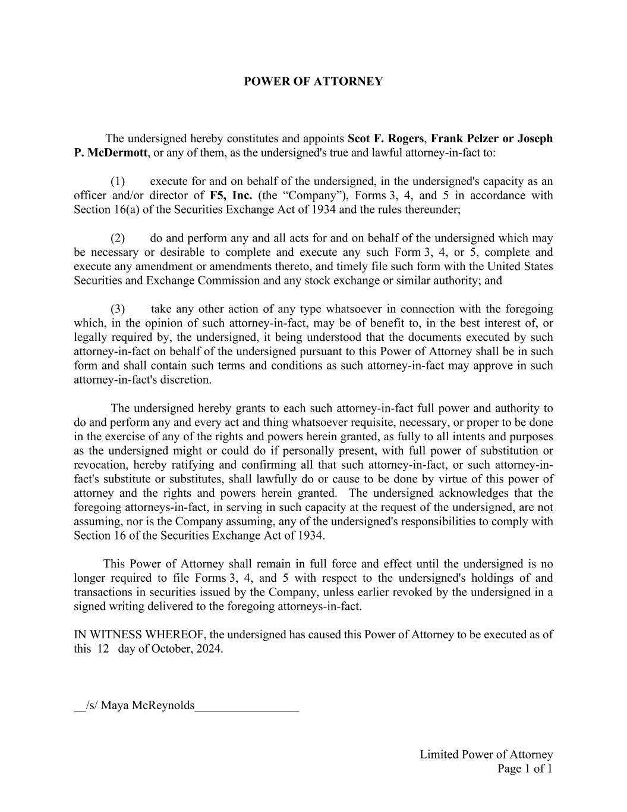
Limited Power of Attorney Page 1 of 1 POWER OF ATTORNEY The undersigned hereby constitutes and appoints Scot F. Rogers, Frank Pelzer or Joseph P. McDermott, or any of them, as the undersigned's true and lawful attorney-in-fact to: (1) execute for and on behalf of the undersigned, in the undersigned's capacity as an officer and/or director of F5, Inc. (the “Company”), Forms 3, 4, and 5 in accordance with Section 16(a) of the Securities Exchange Act of 1934 and the rules thereunder; (2) do and perform any and all acts for and on behalf of the undersigned which may be necessary or desirable to complete and execute any such Form 3, 4, or 5, complete and execute any amendment or amendments thereto, and timely file such form with the United States Securities and Exchange Commission and any stock exchange or similar authority; and (3) take any other action of any type whatsoever in connection with the foregoing which, in the opinion of such attorney-in-fact, may be of benefit to, in the best interest of, or legally required by, the undersigned, it being understood that the documents executed by such attorney-in-fact on behalf of the undersigned pursuant to this Power of Attorney shall be in such form and shall contain such terms and conditions as such attorney-in-fact may approve in such attorney-in-fact's discretion. The undersigned hereby grants to each such attorney-in-fact full power and authority to do and perform any and every act and thing whatsoever requisite, necessary, or proper to be done in the exercise of any of the rights and powers herein granted, as fully to all intents and purposes as the undersigned might or could do if personally present, with full power of substitution or revocation, hereby ratifying and confirming all that such attorney-in-fact, or such attorney-in- fact's substitute or substitutes, shall lawfully do or cause to be done by virtue of this power of attorney and the rights and powers herein granted. The undersigned acknowledges that the foregoing attorneys-in-fact, in serving in such capacity at the request of the undersigned, are not assuming, nor is the Company assuming, any of the undersigned's responsibilities to comply with Section 16 of the Securities Exchange Act of 1934. This Power of Attorney shall remain in full force and effect until the undersigned is no longer required to file Forms 3, 4, and 5 with respect to the undersigned's holdings of and transactions in securities issued by the Company, unless earlier revoked by the undersigned in a signed writing delivered to the foregoing attorneys-in-fact. IN WITNESS WHEREOF, the undersigned has caused this Power of Attorney to be executed as of this 12 day of October, 2024. __/s/ Maya McReynolds_________________

