FORM 3

UNITED STATES SECURITIES AND EXCHANGE COMMISSION
Washington, D.C. 20549

INITIAL STATEMENT OF BENEFICIAL OWNERSHIP OF SECURITIES

OMB APPROVAL
OMB Number: 3235-0104
Estimated average burden
hours per response... 0.5

Filed pursuant to Section 16(a) of the Securities Exchange Act of 1934 or Section 30(h) of the Investment Company Act of 1940

1. Name and Address of Reporting Person *

Werner Edward Cooper
2. Date of Event Requiring Statement (MM/DD/YYYY)
11/19/2024

3. Issuer Name and Ticker or Trading Symbol

F5, INC. [FFIV]
(Last) (First) (Middle)

C/O F5, INC., 801 5TH AVE.
4. Relationship of Reporting Person(s) to Issuer (Check all applicable)

_____ Director _____ 10% Owner
___X___ Officer (give title below) _____ Other (specify below)
Chief Financial Officer /
(Street)

SEATTLE, WA 98104

(City) (State) (Zip)
5. If Amendment, Date Original Filed(MM/DD/YYYY)

6. Individual or Joint/Group Filing(Check Applicable Line)

_X_ Form filed by One Reporting Person
___ Form filed by More than One Reporting Person
Table I - Non-Derivative Securities Beneficially Owned
1.Title of Security
(Instr. 4)
2. Amount of Securities Beneficially Owned
(Instr. 4)
3. Ownership Form: Direct (D) or Indirect (I)
(Instr. 5)
4. Nature of Indirect Beneficial Ownership
(Instr. 5)
Common Stock
2,601
D

Table II - Derivative Securities Beneficially Owned (e.g., puts, calls, warrants, options, convertible securities)
1. Title of Derivate Security
(Instr. 4)
2. Date Exercisable and Expiration Date
(MM/DD/YYYY)
3. Title and Amount of Securities Underlying Derivative Security
(Instr. 4)
4. Conversion or Exercise Price of Derivative Security
5. Ownership Form of Derivative Security: Direct (D) or Indirect (I)
(Instr. 5)
6. Nature of Indirect Beneficial Ownership
(Instr. 5)

Date Exercisable
Expiration Date
Title
Amount or Number of Shares

Restricted Stock Unit ⁽¹⁾
⁽²⁾
⁽³⁾
Common Stock
1,317
$0
D

Restricted Stock Unit ⁽¹⁾⁽⁴⁾
⁽⁵⁾
⁽³⁾
Common Stock
5,436
$0
D

Explanation of Responses:
(1) | Each Restricted Stock Unit represents a contingent right to receive one share of F5, Inc. Common Stock on the vest date.
(2) | The service-based Restricted Stock Units (RSUs) outstanding under this November 1, 2023 grant vest as follows: 329 vest February 1, 2025, 329 vest May 1, 2025, 329 vest August 1, 2025 and 330 vest November 1, 2025.
(3) | If the reporting person continues to provide services to the Company through the vest date, the corresponding number of shares of Common Stock of F5, Inc. will be issued to the reporting person on the vest date.
(4) | Concurrent with the award of 5,436 service-based Restricted Stock Units, the Company granted the reporting person additional Restricted Stock Units the number of which that can be earned will be based on performance targets ("Performance RSUs"). If the performance targets are achieved at 100%, the reporting person can receive 5,436 Performance RSUs over the vesting period; the actual number of Performance RSUs received may be more or less depending on whether and to the extent that performance is greater than or less than targets and may be less if the reporting person does not remain employed during the vesting period. Performance RSUs are not reported in Table II; the underlying shares of Performance RSUs will be reported in Table I if and when the Talent and Compensation Committee of the Board of Directors determines that the performance targets have been achieved.
(5) | This November 1, 2024 award of service-based Restricted Stock Units vests in twelve equal quarterly increments beginning February 1, 2025.

Reporting Owners
Reporting Owner Name / Address

Relationships

Director
10% Owner
Officer
Other
Werner Edward Cooper
C/O F5, INC.
801 5TH AVE.
SEATTLE, WA 98104

Chief Financial Officer

Signatures

/s/ Scot F. Rogers by Power of Attorney

11/20/2024
**Signature of Reporting Person

Date

Reminder: Report on a separate line for each class of securities beneficially owned directly or indirectly.
* | If the form is filed by more than one reporting person, see Instruction 5(b)(v).
** | Intentional misstatements or omissions of facts constitute Federal Criminal Violations. See 18 U.S.C. 1001 and 15 U.S.C. 78ff(a).
Note: | File three copies of this Form, one of which must be manually signed. If space is insufficient, see Instruction 6 for procedure.
Persons who respond to the collection of information contained in this form are not required to respond unless the form displays a currently valid OMB control number.

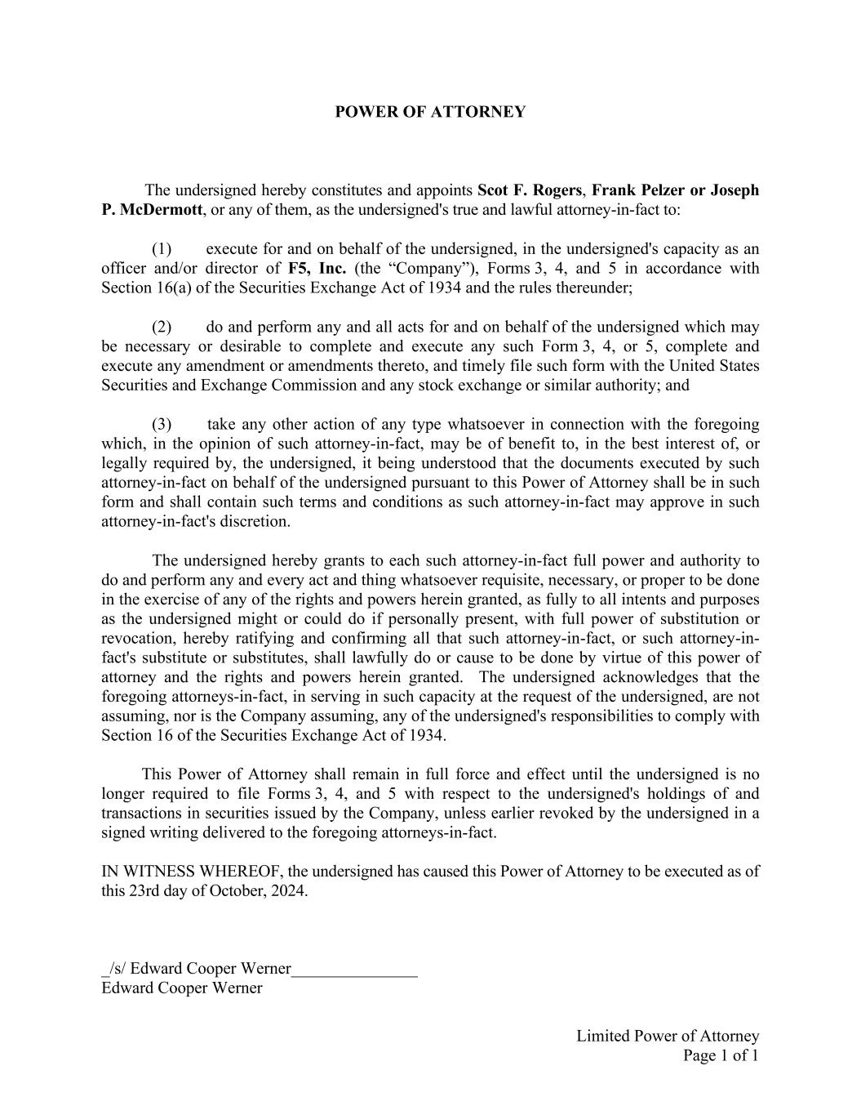
Limited Power of Attorney Page 1 of 1 POWER OF ATTORNEY The undersigned hereby constitutes and appoints Scot F. Rogers, Frank Pelzer or Joseph P. McDermott, or any of them, as the undersigned's true and lawful attorney-in-fact to: (1) execute for and on behalf of the undersigned, in the undersigned's capacity as an officer and/or director of F5, Inc. (the “Company”), Forms 3, 4, and 5 in accordance with Section 16(a) of the Securities Exchange Act of 1934 and the rules thereunder; (2) do and perform any and all acts for and on behalf of the undersigned which may be necessary or desirable to complete and execute any such Form 3, 4, or 5, complete and execute any amendment or amendments thereto, and timely file such form with the United States Securities and Exchange Commission and any stock exchange or similar authority; and (3) take any other action of any type whatsoever in connection with the foregoing which, in the opinion of such attorney-in-fact, may be of benefit to, in the best interest of, or legally required by, the undersigned, it being understood that the documents executed by such attorney-in-fact on behalf of the undersigned pursuant to this Power of Attorney shall be in such form and shall contain such terms and conditions as such attorney-in-fact may approve in such attorney-in-fact's discretion. The undersigned hereby grants to each such attorney-in-fact full power and authority to do and perform any and every act and thing whatsoever requisite, necessary, or proper to be done in the exercise of any of the rights and powers herein granted, as fully to all intents and purposes as the undersigned might or could do if personally present, with full power of substitution or revocation, hereby ratifying and confirming all that such attorney-in-fact, or such attorney-in- fact's substitute or substitutes, shall lawfully do or cause to be done by virtue of this power of attorney and the rights and powers herein granted. The undersigned acknowledges that the foregoing attorneys-in-fact, in serving in such capacity at the request of the undersigned, are not assuming, nor is the Company assuming, any of the undersigned's responsibilities to comply with Section 16 of the Securities Exchange Act of 1934. This Power of Attorney shall remain in full force and effect until the undersigned is no longer required to file Forms 3, 4, and 5 with respect to the undersigned's holdings of and transactions in securities issued by the Company, unless earlier revoked by the undersigned in a signed writing delivered to the foregoing attorneys-in-fact. IN WITNESS WHEREOF, the undersigned has caused this Power of Attorney to be executed as of this 23rd day of October, 2024. _/s/ Edward Cooper Werner_______________ Edward Cooper Werner

